We can create a new form of SVM called dual form as shown below.

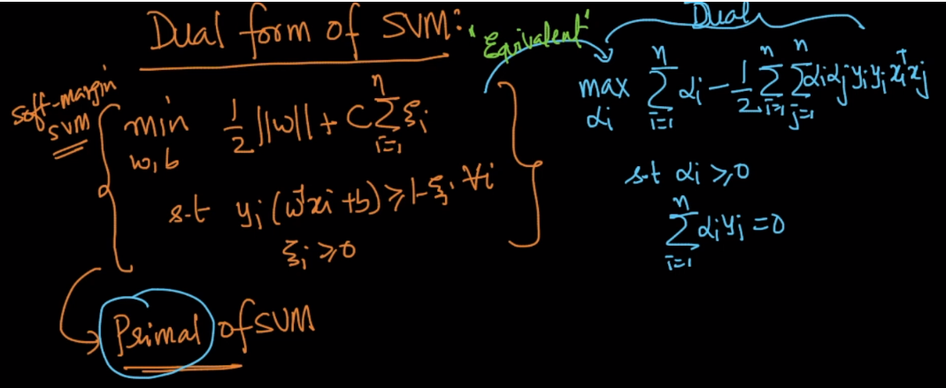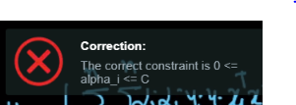

Things there are for dual equation

* For each x_i or data point there is a alpha
* X_i’s occur only in form of dot product with other X_j
* Function we obtain for final classification is given below.
* alpha > 0 for support vectors

And alpha = 0 for non support vectors.

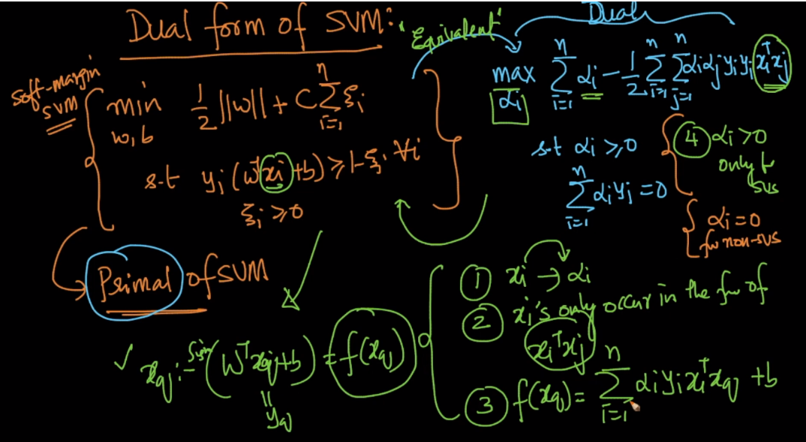

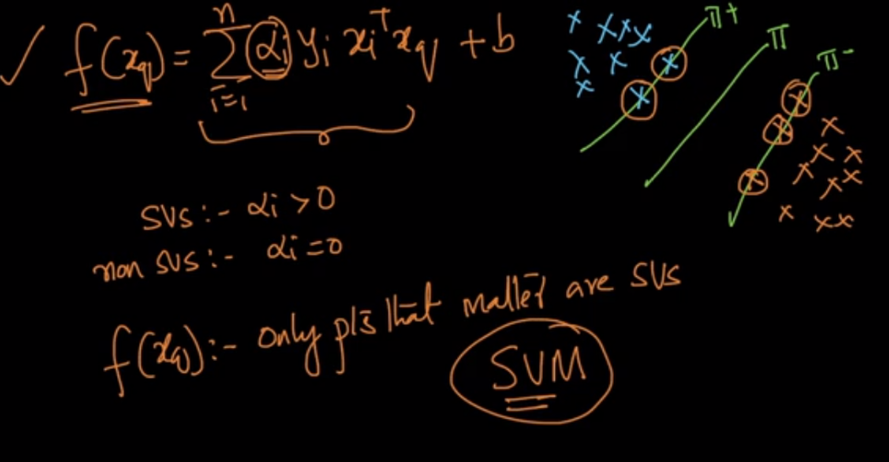

The advantage we have in dual formulation is that we can place similarity function in place of x_i_T . x_j.

Or we can place any kernel there.

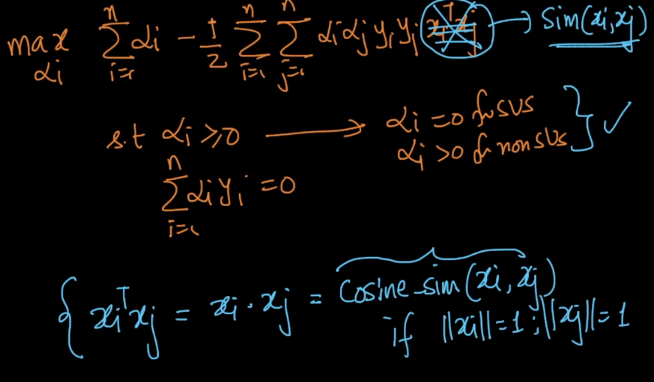

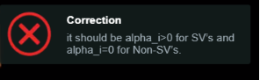

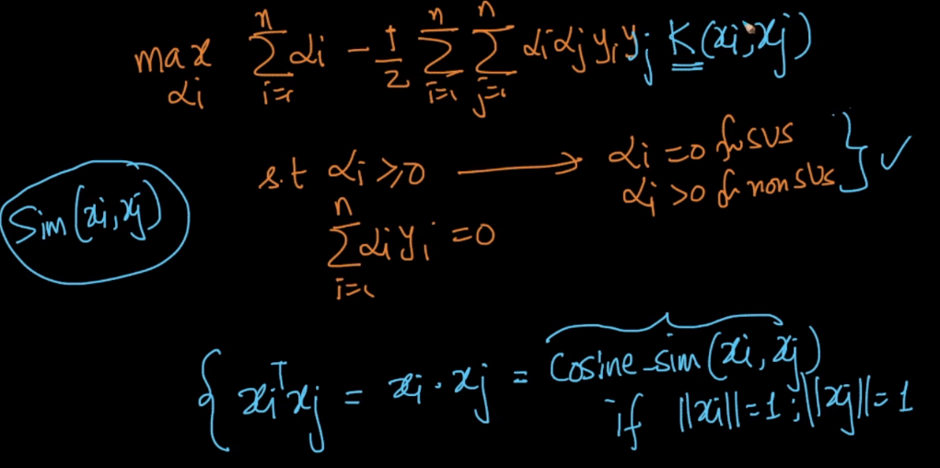

So our final function which classifies every new datapoint. Is given below, here we can see dot product of x can be replaced with any kernel

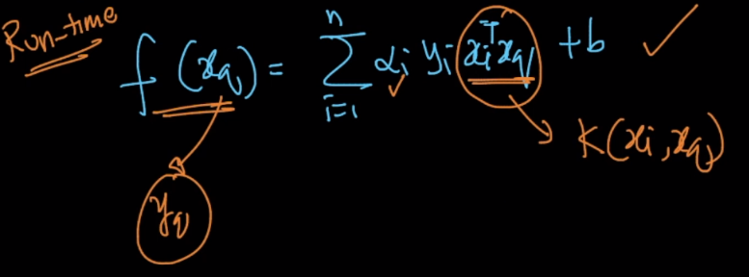

To learn more about this: <https://medium.com/@ashwanibhardwajcodevita16/from-zero-to-hero-in-depth-support-vector-machine-264931a1e135>